Name : Khush Pithva 24BCE174
Subject : Data Structure (2CS501)
Practical no.: 2A
AIM : Create a singly linked list and perform following operations using menu driven approach:
  - Create a linked list
  - Delete a node if it is found, otherwise display an appropriate message
  - Search a given integer value in the list
  - Display the linked list

INPUT :
#include <bits/stdc++.h>
using namespace std;

struct node {
int rollno;
node* next;
};

class ll
{
private:
node* head;

public:
ll()
{
head = nullptr;
}

void createList()
{
int value;
node* temp = nullptr;
int n;
cout << "Enter the number of nodes: ";
cin >> n;

if (n <= 0)
{
cout << "No nodes to create.\n";
return;
}

for (int i = 0; i < n; i++)
{
cout << "Enter roll number " << i + 1 << ": ";
cin >> value;
node* newnode = new node{value, nullptr};
if (head == nullptr)
{
head = newnode;
temp = head;
}
else
{
temp->next = newnode;
temp = newnode;
}
}
}

void displayList() const
{
if (head == nullptr) {
cout << "List is empty.\n";
return;
}

node* temp = head;
cout << "\nStudent Roll Numbers in the List:\n";
while (temp != nullptr)
{
cout << "Roll Number: " << temp->rollno << endl;
temp = temp->next;
}
}

void findRollno(int k) const
{
if (head == nullptr)
{
cout << "List is empty. Can't search.\n";
return;
}

node* temp = head;
while (temp != nullptr) {
if (temp->rollno == k) {
cout << "Roll Number " << k << " is found in the list.\n";
return;
}
temp = temp->next;
}
cout << "Roll Number " << k << " not found in the list.\n";
}

void deletenode()
{
if (head == nullptr) {
cout << "List is empty. Cannot delete.\n";
return;
}

int n;
cout << "Enter the roll number of the node to be deleted: ";
cin >> n;

node* temp = head;
node* prev = nullptr;

while (temp != nullptr && temp->rollno != n)
{
prev = temp;
temp = temp->next;
}

if (temp == nullptr) {
cout << "Roll Number " << n << " not found. Cannot delete.\n";
return;
}

if (prev == nullptr) {
head = head->next;
} else {
prev->next = temp->next;
}

delete temp;
cout << "Roll Number " << n << " deleted successfully.\n";
}

~ll()
{
while (head != nullptr) {
node* temp = head;
head = head->next;
delete temp;
}
}
};

int main() {
ll list;
int choice, k;

list.createList();

while (true)
{
cout << "\nMenu:\n1. Display List\n2. Find Roll Number\n3. Delete Node\n4. Exit\nEnter your choice: ";
cin >> choice;

switch (choice)
{
case 1:
list.displayList();
break;
case 2:
cout << "Enter roll number to find: ";
cin >> k;
list.findRollno(k);
break;
case 3:
list.deletenode();
break;
case 4:
cout << "Exiting program.\n";
return 0;
default:
cout << "Invalid choice.\n";
}
}

return 0;

}OUTPUT :
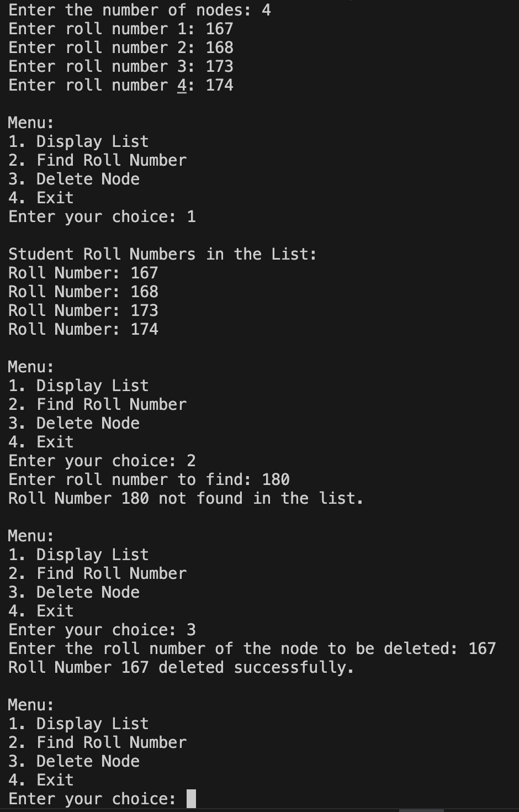

Practical no.: 2B
AIM : Write a program to implement polynomial addition using linked list.

INPUT :
#include <iostream>
using namespace std;

// Define structure for polynomial term
class Node {
public:
int coeff;
int exp;
Node* next;

Node(int c, int e) {
coeff = c;
exp = e;
next = nullptr;
}
};

// Function to insert a term at the end of linked list
Node* insertTerm(Node* head, int coeff, int exp) {
Node* newNode = new Node(coeff, exp);
if (head == nullptr) return newNode;

Node* temp = head;
while (temp->next)
temp = temp->next;

temp->next = newNode;
return head;
}

// Function to display a polynomial
void displayPoly(Node* poly) {
while (poly) {
cout << poly->coeff << "x^" << poly->exp;
poly = poly->next;
if (poly) cout << " + ";
}
cout << endl;
}

// Function to add two polynomials
Node* addPolynomials(Node* poly1, Node* poly2) {
Node* result = nullptr;

while (poly1 && poly2) {
if (poly1->exp > poly2->exp) {
result = insertTerm(result, poly1->coeff, poly1->exp);
poly1 = poly1->next;
}
else if (poly1->exp < poly2->exp) {
result = insertTerm(result, poly2->coeff, poly2->exp);
poly2 = poly2->next;
}
else { // Same exponent
int sum = poly1->coeff + poly2->coeff;
if (sum != 0) // Avoid inserting zero coefficient
result = insertTerm(result, sum, poly1->exp);
poly1 = poly1->next;
poly2 = poly2->next;
}
}

// Add remaining terms
while (poly1) {
result = insertTerm(result, poly1->coeff, poly1->exp);
poly1 = poly1->next;
}

while (poly2) {
result = insertTerm(result, poly2->coeff, poly2->exp);
poly2 = poly2->next;
}

return result;
}

// Main function
int main() {
Node* poly1 = nullptr;
Node* poly2 = nullptr;

// Polynomial 1: 3x^3 + 4x^2 + 2
poly1 = insertTerm(poly1, 3, 3);
poly1 = insertTerm(poly1, 4, 2);
poly1 = insertTerm(poly1, 2, 0);

// Polynomial 2: 5x^2 + 6x + 1
poly2 = insertTerm(poly2, 5, 2);
poly2 = insertTerm(poly2, 6, 1);
poly2 = insertTerm(poly2, 1, 0);

cout << "Polynomial 1: ";
displayPoly(poly1);

cout << "Polynomial 2: ";
displayPoly(poly2);

Node* result = addPolynomials(poly1, poly2);
cout << "Sum: ";
displayPoly(result);

return 0;
}
OUTPUT :

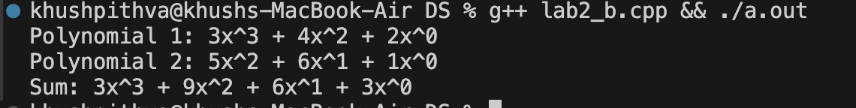
LEETCODE
- Reversed Linked List

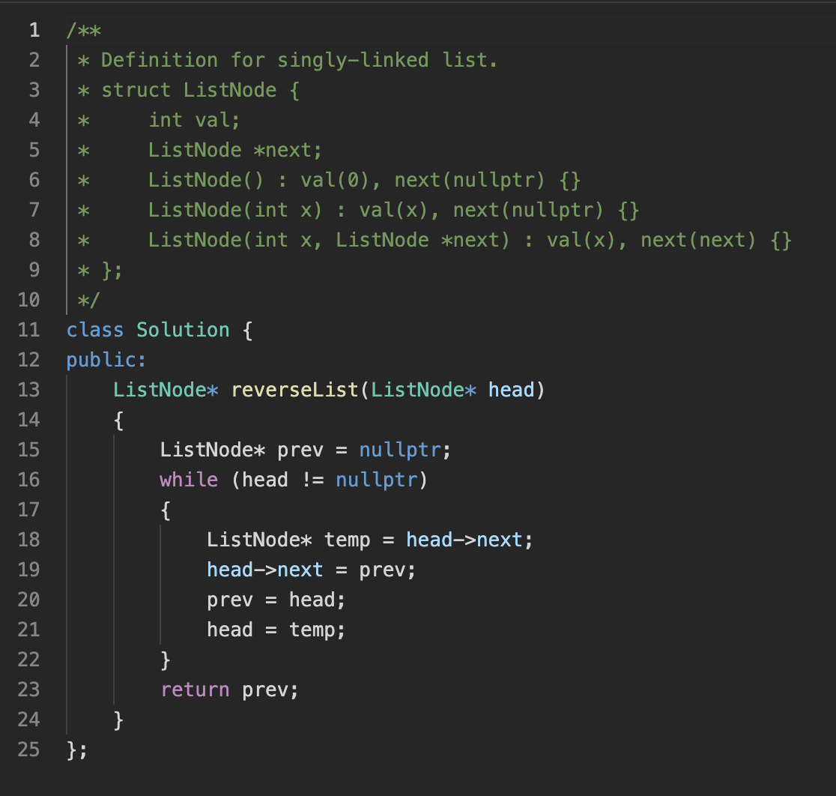
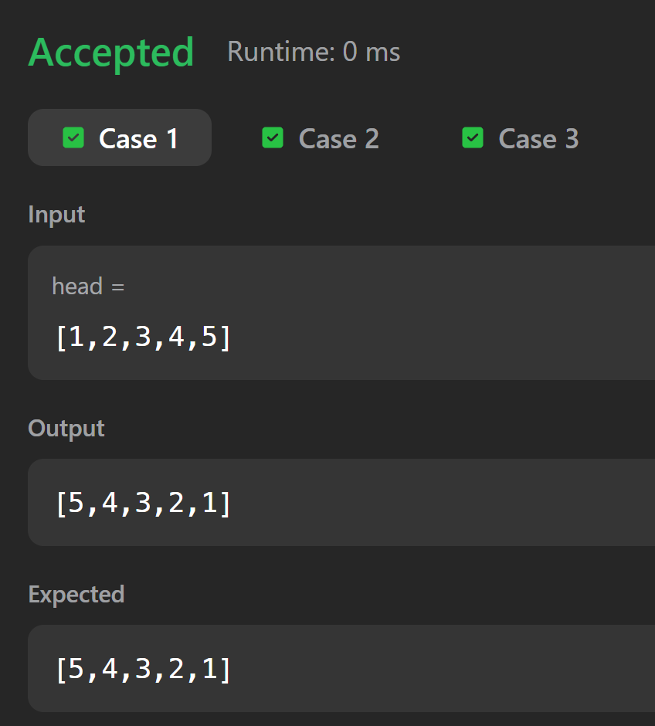

- Linked List Cycle
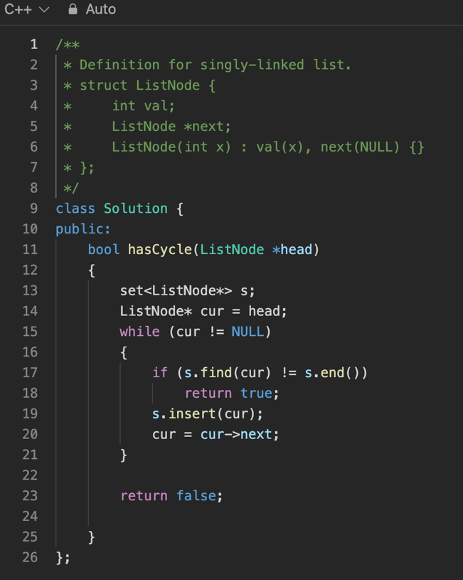
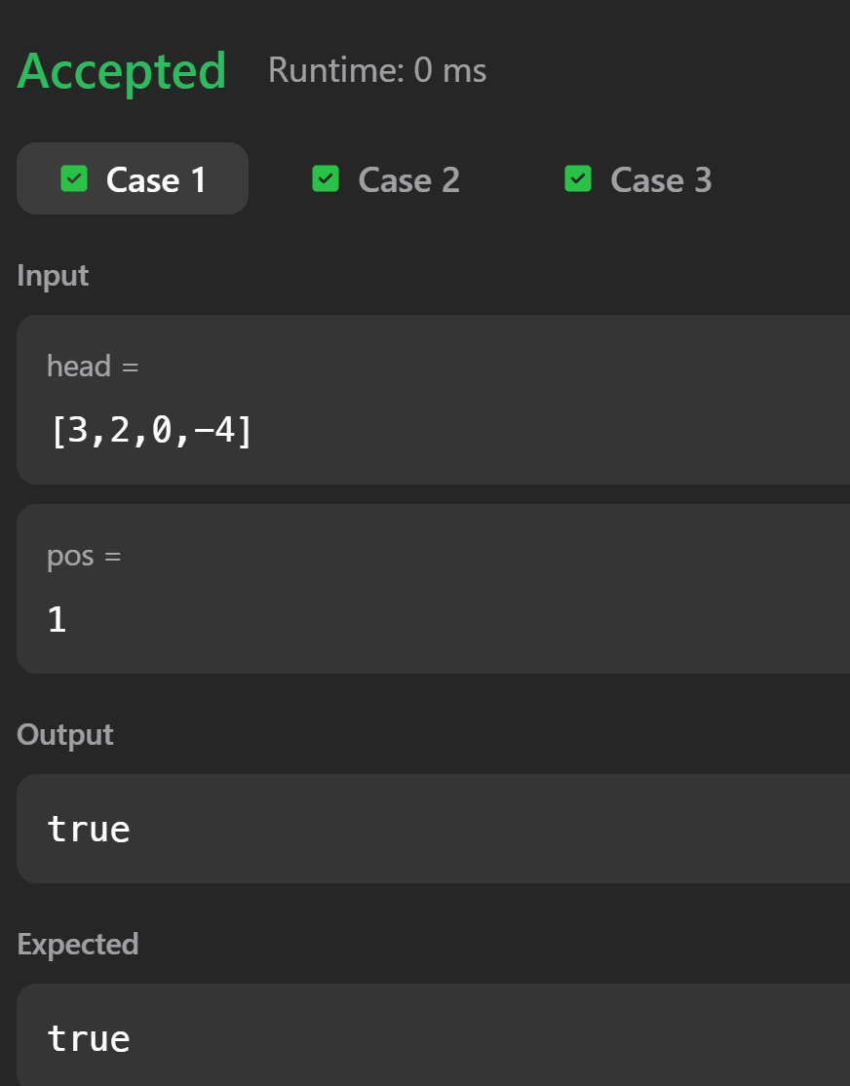

- Add Two Numbers
